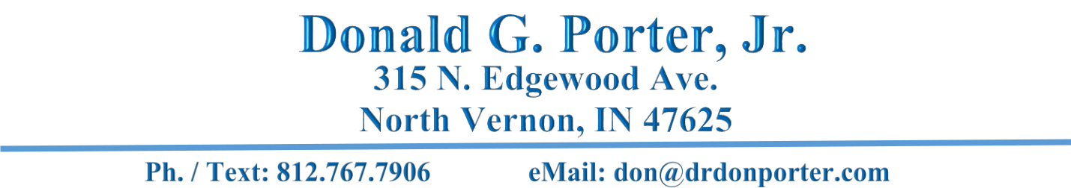

Objective: To contribute to the academic and practical growth of students utilizing lecture, dialogue, textual, and hands-on projects that develop critical and analytical mental skills, and practical application, of life skills for success in their future endeavors.

SECONDARY/ POST-SECONDARY TEACHING

An experienced teacher committed to facilitating learning, and utilizing knowledge in curriculum development and instructional technology. Skilled in the following areas:

• Multi-environment teaching (Classroom,

Video, Open-air, Museums)

• Classroom management and organization

• Staff education and training

• Quality improvement initiatives

• Encouraging continuing education

• Lesson Plan Development

• Delivering curriculum assessments and

implementing time-constrained courses

• Student assessment

• Individual-focused learning and recognizing

achievement

TEACHING EXPERIENCE

Lab Tech 2018 – 2021
Ivy Tech Community College, Madison, IN

Adult Ed Teacher 2018 – 2020
River Valley Resources, Madison, IN

Adjunct Professor (temp contract) 2013
Oakland City University, IDOC, Madison, IN

• Survey of Accounting

Indiana Permitted Substitute Teacher 2009
Bartholomew County School Corporation, Columbus, IN

- Assisted in mastery outcomes for mentally challenged students in guided learning, recreational activities, tactile and visual intervention

  - Guided students in disciplinary positive reinforcement
    - Engaged students with multi-media presentations

Facilitator/ Teacher 2006-2007
Southern Indiana Baptist College, DuPont, IN

- Assisted with the multimedia curriculum by creating audio and written materials
    - Facilitated teaching multiple courses to adult learners
  - Assisted with negative accounts payable for delinquent students

Indiana Permitted Substitute Teacher 2005-2006
Jennings County School Corporation, North Vernon, IN

  - Taught in a classroom for about 200 hours with various grade levels
- Taught elementary and secondary classes with a 20-30 student class size

• Implemented daily lesson plans for diverse subjects

Administrator/ Instructor 2001-2002
Butlerville Christian Academy, North Vernon, IN

              - Managed and instructed K-10 students.
        - Evaluated an implemented curriculum for private schools in the state of Indiana
          - Maintained the path for teachers continuing education and development
      - Facilitated parent communication sessions, student social activities, and fundraisers

    - Fostered an open-door policy for complaints and concerns, in addition to maintaining weekly and yearly student assessment and evaluation

- Performed daily administrative duties involving tuition and expense management, curriculum ordering, student file maintenance, facilities management, and attendance policy adherence.

            - Implemented a computerized reading system.

  - Created an atmosphere of individualized student performance that included self-paced success, group and personal motivation, and evaluation toward chronological grade achievement

Staff Trainer 1990-1994
Columbus Regional Hospital, Columbus, IN

- Trained staff across diverse professional backgrounds on fire safety, access control, and personal safety
  - Used local emergency services for practical hands-on training
    - Used various visual training aides in group sessions

EDUCATION
Doctor of Ministry: 2018
School of Bible and Theological Studies, Florida Campus

Concentration: Biblical Studies and the American Founding
Dissertation: Technology, The Catalyst for Learning

Master of Education 2004 American Intercontinental University, Schaumburg, IL • Concentration: Instructional Technology

Bachelor of Science in Business Administration 1999 Trinity College & University, Metairie, LA • Concentration: Management

PROFESSIONAL TRAINING & WORKSHOPS Strategic Communication, Purdue University Extension Course Jennings County High School Improvement Committee – North Vernon, IN School of Tomorrow Administrator’s Training Certificate – Lewisville, TX Front-Line Leadership, Ivy Tech State College – Columbus, IN Quality Series on Leadership, Columbus Regional Hospital – Columbus, IN

AFFILIATIONS
Member of CUE – Computer-Using Educators
Member of CEAI – Christian Educators Association International
Member of AACS – American Association of Christian Schools

